**The KD2BD Pacsat Modem**

**By: John A. Magliacane, KD2BD**

This paper was originally published in the August 1994 issue of QEX: The ARRL Experimenter's Exchange. It was later published in the July/August 1995 issue of the AMSAT Journal, as well as the first edition of the ARRL's Packet: Speed, More Speed and Applications.

The KD2BD Pacsat Modem is a low cost, high performance 1200 bps BPSK modem designed to interface between a packet radio terminal node controller (TNC) and an amateur satellite ground station, and allows full-duplex access to the 1200 baud "Pacsat" constellation of amateur satellites.

Important features of this modem include:

* High immunity to noise and interference
* "Matched filter" demodulator performance
* Non-limiting (linear) balanced phase detection
* Wide range automatic gain control
* Doppler correcting AFC for the downlink receiver
* Compatible with current and future Pacsats
* Uses readily available components
* Easily interfaces with standard TNCs
* Operates from a single +12v DC power supply
* Suitable for terrestrial communications
* Provides outstanding performance

The KD2BD Pacsat Modem consists of a 1200 bit per second BPSK demodulator for receiving Pacsat transmissions, and a Bi-Phase Manchester encoder for generating Pacsat uplink signals. The demodulator uses coherent phase detection and correlation decoding techniques that are capable of demodulating BPSK signals well into the noise level. It also includes an Automatic Gain Control (AGC) system to compensate for signal strength variations, and an Automatic Frequency Control (AFC) for tuning the downlink receiver in response to Doppler shift during a satellite pass. The demodulator is very sensitive, and is capable of locking into BPSK signals so weak they are barely audible above the ambient receiver noise. The modulator produces low-distortion 1200 bit per second Bi-Phase Manchester code suitable for generating Manchester encoded FSK when used with a standard 2-meter FM voice transmitter, or BPSK when used with an SSB transmitter.

The KD2BD Pacsat Modem was originally designed to interface with an MFJ 1270B terminal node controller (TNC-2 clone), and a Yaesu FT-726R multi-mode VHF/UHF communications transceiver. Suitable interfacing modifications should allow proper modem operation with other TNCs and ground station radio equipment. The specifics for doing so are left to the expertise of the reader.

**The Pacsats**

Orbital Satellites Carrying Amateur Radio (OSCARs) have been a part of amateur radio for over 30 years. With the growing popularity of terrestrial packet radio communications on the amateur bands, recent OSCAR satellites have been designed to make use of the AX.25 protocol in their communications with ground stations. Some satellites, such as DOVE-OSCAR-17, use the protocol for the transmission of telemetry information through beacon transmitters, while others use the protocol to provide full duplex communication links with the satellites' transponders. Amateur satellites containing packet radio store-and-forward transponders are known as "Pacsats".

The current roster of satellites making 1200 bps NRZI, HDLC, AX.25 protocol compatible packet radio transmissions on amateur frequencies includes PACSAT-OSCAR-16, DOVE-OSCAR-17, WEBERSAT-OSCAR-18, LUSAT-OSCAR-19, FUJI-OSCAR-20, ITAMSAT-OSCAR-26, and FUJI-OSCAR-29.

Of these satellites, only DOVE-OSCAR-17 uses audio frequency shift keying (AFSK) modulation on a narrow-band FM carrier which is compatible with existing terrestrial VHF-FM and UHF-FM packet radio communications. The remaining satellites use binary phase shift keying (BPSK) modulation. As popular and as widespread as the AFSK-FM method of transmission is for 1200 baud packet radio communications, AFSK-FM and its popular demodulation methods yield a level of performance that leaves a lot to be desired. Steve Goode, K9NG, has shown through extensive testing that a Tucson Amateur Packet Radio (TAPR) TNC-1 internal Bell 202 modem required a signal level that produced at least 25 dB of FM receiver quieting (25 dBQ) for high communications reliability. Since this is a difficult signal level to achieve from micro satellites operating on UHF frequencies with only several watts of transmitter power, a more robust Binary Phase Shift Keying (BPSK) emission was selected for use by 1200 bps Pacsat downlink transmitters.

**Binary Phase Shift Keying**

Coupled with low binary data rates, Binary Phase Shift Keying has allowed interplanetary space probes to transmit vast quantities of data to ground stations on Earth from great distances with low transmitter power. BPSK offers a 6 dB signal-to-noise ratio advantage over coherent CW (CCW) modulation. CCW has long been considered to be the premium weak signal communications mode available to amateurs.

BPSK is produced by modulating a carrier oscillator with binary modulating information in a balanced modulator. The resulting BPSK emission can be analyzed several ways, depending on whether the analysis is performed in the time domain or the frequency domain. In the time domain, the BPSK signal looks similar to the local carrier introduced to the modulator except its phase shifts by 180 degree intervals with binary modulation. In the frequency domain, BPSK looks similar to a double sideband suppressed carrier AM signal centered about its local suppressed carrier frequency.

**BPSK Signal Processing**

Figure One is a block diagram of the KD2BD Pacsat Modem. The demodulator is designed to operate with an SSB receiver properly tuned to the frequency of a BPSK transmitter. In essence, the SSB receiver merely acts as a frequency converter, translating the RF BPSK signal captured by the ground station antenna down to the audio frequency range where it can be easily processed by the demodulator using audio circuitry.

The BPSK signal applied to the input of the modem branches in two separate directions within the demodulator. One path extracts, processes, and regenerates the BPSK carrier, while the second performs BPSK signal detection and filtering.

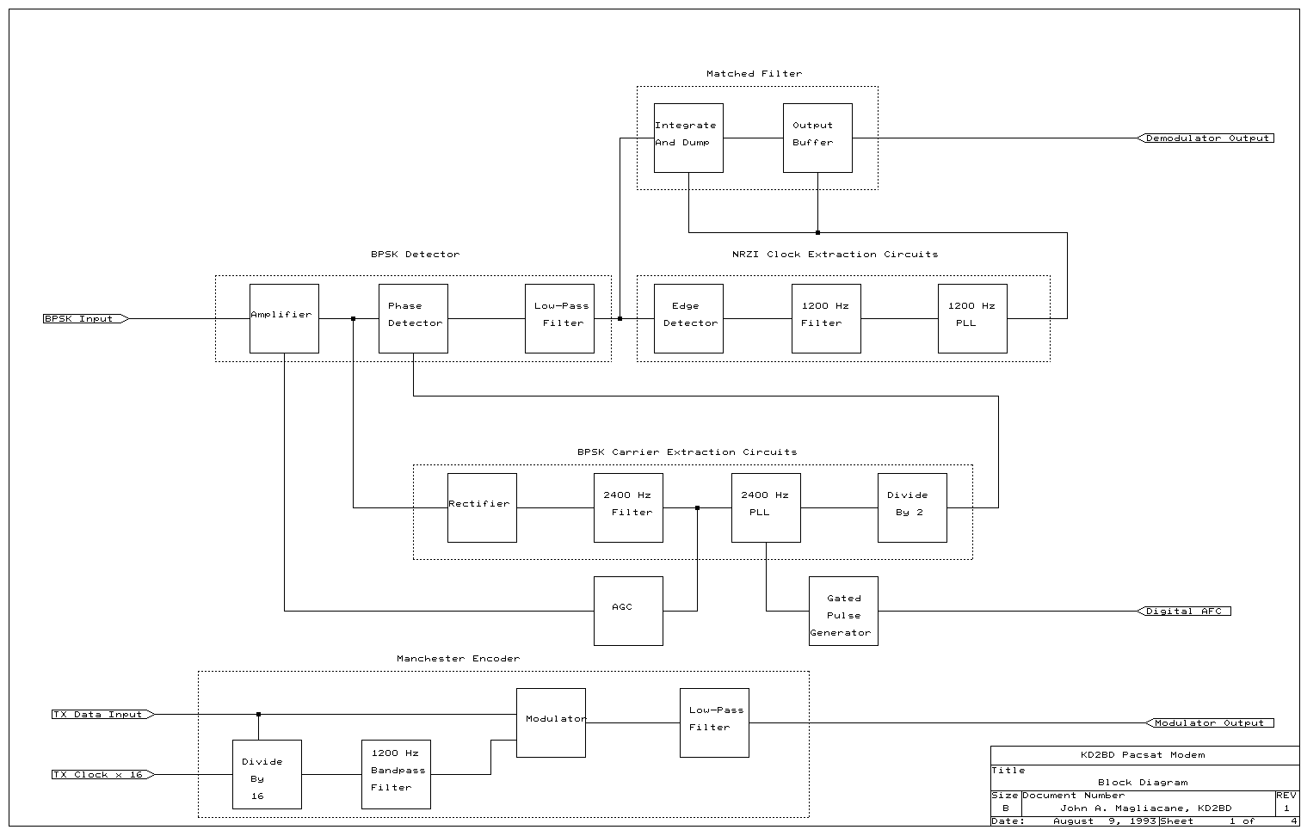

Figure 1: Functional block diagram of the KD2BD Pacsat Modem.

**BPSK Carrier Recovery**

BPSK signals in this modem design are demodulated synchronously, and synchronous detectors require a reference carrier for phase determination. Since the BPSK transmitter suppresses its carrier in its balanced modulator, there is no clearly defined reference present in a BPSK signal. The demodulator must therefore synthesize a BPSK reference carrier from sideband components present in the composite BPSK signal. If viewed in the time domain, the carrier of a signal whose phase shifts by 180 degree intervals may be extracted by taking the absolute value of the BPSK waveform voltage and filtering the result. A full-wave rectifier can be used to perform the absolute value function. The rectification process yields a waveform of constant phase and frequency twice that of the BPSK suppressed carrier. In the frequency domain, the rectifier may be thought of as being a non-linear circuit that mixes the upper and lower BPSK sidebands producing the algebraic sum of those sidebands. Dividing the frequency of this product by two produces a local carrier of constant phase whose frequency equals that of the suppressed BPSK carrier.

Referring to the schematic diagram of the KD2BD Pacsat Modem shown in Figure Two, the received BPSK signal is first passed through a current variable input attenuator. Resistor R1 acts as the series element of an "L" attenuator. Diodes D1 and D2, that act as current variable resistances form the shunt element. The AGC voltage that drives the input attenuator is derived from the filtered BPSK carrier.

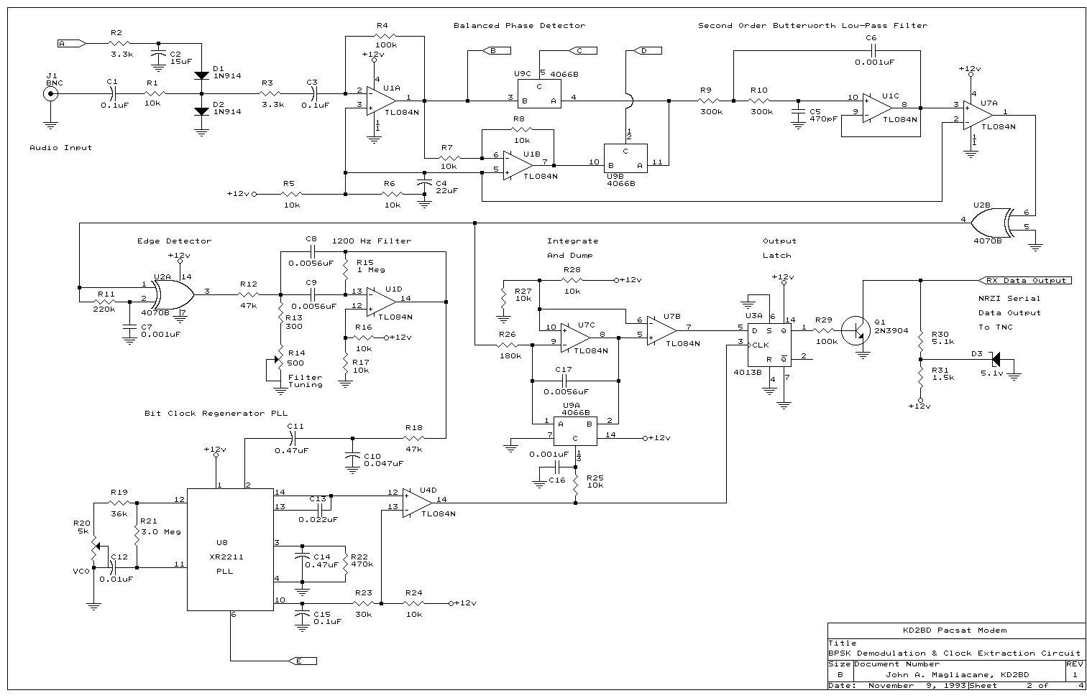

Figure 2: Schematic showing the receive input circuit, phase detector and filter, and bit-clock regenerator.

The level controlled BPSK signal is passed through input amplifier U1A, after which it is split between the balanced phase detector and the carrier extraction circuits. The amplified BPSK signal is processed through a precision full-wave rectifier circuit built around U4A and U4B, two sections of a TL084N quad bi-fet operational amplifier. The output voltage of the full-wave rectifier is the absolute value of the incoming BPSK signal. If the downlink receiver is tuned such that the BPSK suppressed carrier is at a frequency of 1200 Hz, then the output of the rectifier will contain a strong product at twice this frequency, or 2400 Hz. Not only does the rectifier mix the BPSK sidebands together, but it also mixes noise components together creating even greater noise energy at the rectifier output. In an effort to remove the undesired noise, the rectifier output is filtered through a narrow bandwidth bandpass filter built around op-amp U4C. This filter has a center frequency of 2400 Hz, a bandwidth of 120 Hz and a Q of 20. The filtered carrier is further processed through U5, an XR2211 Phase Locked Loop FSK Demodulator/Tone decoder circuit with a loop bandwidth of 120 Hz. The XR2211 offers outstanding frequency stability and provides several output signals and other features used for receiver automatic frequency control (AFC) and data carrier detection (DCD). The Phase Locked Loop regenerates the 2400 Hz carrier, producing a noise-free waveform of constant amplitude locked in frequency and in phase with that of the BPSK carrier.

The Phase Locked Loop's oscillator is extracted from pin 14, shaped to a pulse waveform through op-amp U7D, and applied to U3B, a "D" flip flop configured as a frequency divider. Toggling on the rising edge of each input pulse, the flip flop divides the frequency of the PLL oscillator by two, reproducing the 1200 Hz BPSK carrier with a 50% duty cycle as required for proper operation of the phase detector.

The output of the 2400 Hz bandpass filter is also passed through a half-wave peak voltage doubler and filter to generate a DC control voltage for the automatic gain control system. Deriving the control voltage from the filtered BPSK carrier results in an AGC that is virtually immune to noise and interference that could otherwise affect the AGC and lead to demodulator desense. The AGC control voltage also drives a front panel tuning and signal strength meter.

**BPSK Signal Detection**

The second path the received BPSK signal takes is the one that actually extracts intelligence from the BPSK signal. A non-limiting, balanced linear phase detector composed of operational amplifier U1B and CMOS switches U9B and U9C is used to translate the BPSK input signal down to baseband levels. The phase detector is driven by the locally generated BPSK carrier supplied by U3B, and offers high local carrier suppression and does not distort the wave shape of the BPSK signal. It also helps to remove noise and other interference not in phase with the desired BPSK signal.

In this design, linear AGC is used rather than hard limiting to maintain a constant output voltage from the detector. As a result, strong input noise does not corrupt weak BPSK signals since there is no limiter or associated "capture effect" to suppress the weaker signal. Since the phase detector switches at the zero crossing point of the sinusoidal BPSK waveform, the detrimental effects of phase jitter and transmitted phase noise are minimized.

The output of the phase detector is gently filtered through a second-order Butterworth low-pass filter to remove higher order products generated by the coherent demodulation process. The frequency response of the filter loosely approximates that of the transmitted BPSK spectra, and its smoothed output voltage is a function of how well the phase of the BPSK signal correlates with that of the locally generated carrier. A perfect correlation produces a maximum output voltage of one polarity, while a correlation of opposite phase produces an output voltage of opposite polarity.

**NRZI Data Encoding**

The AX.25 packet radio communications protocol uses a data encoding technique known as NRZI, Non Return to Zero Inverted. NRZI synchronous data encoding packs both data and clock information into one binary serial data stream. An NRZI receiver is edge triggered rather than level triggered, and must therefore be sensitive to logic level transitions and extract clock and data information from those transitions. With NRZI, a '0' data bit is encoded as a bit level transition, while a '1' is encoded as no transition. The AX.25 protocol uses a process called zero insertion or "bit stuffing" that ensures that no more than five '1's can occur sequentially except when flag bytes are transmitted. Flags are used to identify the beginning and ending of each packet frame.

Zero insertion in combination with NRZI encoding guarantees that a logic level transition occurs at least once every five bit periods. These frequent level transitions are necessary to allow the modem and TNC to synchronize with the transmitting TNC's clock.

**Post Detection Filtering**

In order to achieve the maximum demodulator performance possible, the detected NRZI encoded serial data stream must be filtered to remove as much noise as possible without introducing distortion that could lead to data corruption. The detected baseband NRZI serial data stream present after the Butterworth filter branches in two separate paths. One branch extracts and regenerates the 1200 Hz bit clock from the NRZI encoded data stream, while the other filters the NRZI data through an "integrate and dump" processor that forms a matched output filter.

**Bit Clock Regeneration**

The unprocessed NRZI encoded serial data stream from the detector is shaped to a square wave of constant amplitude through op-amp U7A and further buffered through exclusive-OR gate U2B. The NRZI data is then fed through an edge detector to extract clock pulses from the detected waveform. The edge detector acts as a frequency doubler by multiplying the NRZI serial data stream by itself delayed by one half of one bit period. The RC network composed of R11 and C7 provides a one half-bit delay, while exclusive-OR gate U2A performs the multiplication. The edge detector produces an output pulse for every NRZI logic level transition received. These pulses are in phase with the embedded NRZI clock signal and are filtered by a 1200-Hz narrow bandpass filter, U1D. This filter receives excitation from the edge detector and produces a damped sine wave by virtue of its high 'Q' and the "flywheel effect". Its purpose is to use stored energy to fill in the gaps during periods when NRZI bit transitions do not occur and clock pulses cannot be recovered from the edge detector. The damped sine wave output of this filter feeds U8, an XR2211 PLL with a center frequency of 1200 Hz and a loop bandwidth of 15 Hz. The phase locked loop follows the average phase and frequency of the filtered NRZI clock pulses, and provides precise timing signals required for operating the "integrate and dump" processor.

**Integrate And Dump**

Maximum received signal-to-noise ratio (SNR) is achieved in a communications system when the bandpass of a receiver exactly matches the bandwidth of the transmitted signal. In order to achieve maximum signal-to-noise ratio, the post detection filtering in this modem is performed with a filter matched to the AX.25 binary data rate of 1200 bps. Unlike simple RC or LC filters, the integrate and dump processor operates in the time domain and is implemented with a resettable integrator and an output latch driven by 1200 Hz clock pulses recovered from the 1200 bps NRZI encoded data stream. With a matched filter, the demodulator's output signal-to-noise ratio is dependent not on the received signal-to-noise ratio, but rather on the ratio of the signal energy to the power spectral density of the noise at the filter's input. A matched filter allows the successful recovery of weak signals buried deep in wideband noise, and offers the smallest error probability that can be achieved and the best bit error rate performance possible over an additive white Gaussian noise channel.

The unprocessed NRZI serial data stream from the phase detector is integrated over each bit interval and the result is sampled by an output latch. During each bit interval, random noise energy will accumulate no charge across integration capacitor C17, while an input signal coherent with the demodulator's internal BPSK reference carrier will accumulate a charge either above or below this point depending on its phase. After approximately 90 percent of the bit interval has passed, the voltage integrated over this period is sampled and evaluated by comparing it to a reference voltage equal to half the supply voltage. Operational amplifier U7B operating as a voltage comparator performs this evaluation. The result is sampled and latched by U3A, the CD4013B output buffer. If the integrated .voltage is above the +1/2 Vcc reference, the output buffer latches to a logic level '1'. If it is below this level, the CD4013B buffer outputs a '0'.

Shortly after the output has latched, the integrator capacitor is discharged and the process repeats for the next data bit. This time averaging process of integrating, sampling, latching, and dumping produces a well-filtered serial data stream re-timed to the recovered NRZI clock signal. The output of matched filter is then converted to TTL levels of 0 and +5 volts through transistor Q1, and made available for processing by the terminal node controller.

**Handshaking Controls**

U5, the XR2211 phase locked loop used for BPSK carrier regeneration contains an "in-phase" (I channel) detector to indicate whether or not the PLL is locked in frequency and phase with its input signal. Since the PLL's input in this case is a product of the BPSK carrier, the "in-phase" detector indicates the presence or absence of a valid BPSK carrier on the modem's input. U8, the XR2211 PLL used for bit clock regeneration contains a similar "in-phase" detector. In this case, the detector indicates the presence of valid 1200 bit per second clock pulses extracted from the BPSK input signal. The active low, open collector outputs of both these detectors are combined by connecting their outputs together. This combined output is pulled to ground level when no carrier and no clock pulses are detected, and to +5 volts when both a carrier and a 1200 bps clock stream are present. It is buffered by Q4 to drive LED indicator D10 and is made available to the TNC as a data carrier detect (DCD) control signal on the output of the modem. The DCD line connects to the TNC serial I/O circuits, and provides for on-the-air flow control and protocol timing. The use of combined carrier and clock detection results in a DCD that is very immune to noise and triggering from false signals.

**Automatic Frequency Control**

Radio links between satellites and ground stations experience Doppler effects due to satellite motion and the Earth's rotation. For an amateur radio spacecraft in a low-Earth orbit of about 1000 km transmitting on UHF, the magnitude of Doppler shift can be as much as 20 kHz, with a maximum rate of change of 40 Hz per second at the time of closest approach on an overhead pass. With the BPSK demodulator designed for a signal properly tuned to within a few tens of Hertz, it is necessary to use an automatic frequency control system to keep the downlink receiver properly tuned to a BPSK transmission during a satellite pass.

An internal voltage comparator in U5 that is normally used for FSK decoder applications of the XR2211 controls the logic of the Automatic Frequency Control circuitry. The comparator compares the PLL error voltage to a reference within the chip. If the error voltage exceeds limits dictated by the PLL's loop bandwidth, it is an indication that the BPSK signal is not properly in tune and the AFC circuitry is activated to affect a correction. If the signal is tuned too high in frequency, the comparator output voltage at pin 7 is pulled low, but only if a valid BPSK carrier is detected on the input of the modem. If the voltage at pin 7 goes low, it allows the LM555 gated oscillator to run stepping the downlink receiver lower in frequency in compensation for Doppler shift. The receiver frequency is controlled through a connection available on the transceiver's microphone connector. Once the receiver frequency has been corrected, the comparator output voltage at pin 7 returns high, disabling the LM555 oscillator, keeping the receiver's frequency fixed until the next correction is required.

Note that the AFC circuit employed in this modem can tune the receiver in one direction only. Since the Doppler Effect causes the signal received from a satellite in Earth orbit to drift lower in frequency during a pass and never higher, it is only necessary to have the receiver tune lower in frequency to compensate for the motion of the satellite. Front panel switch SW1 enables the operator to disable the AFC feature of the modem during manual receiver tuning.

Two digital AFC pulse polarities are produced by the modem. Output "AFC +" produces a positive output voltage with respect to ground every time the ground station receiver must be tuned. This polarity is consistent with that required for Yaesu FT-726R transceiver tuning. Others require a switch to ground, as provided by the "AFC -" output.

The ground station receiver must be capable of tuning in 20 Hz incremements or less. If this is not possible, then it will be necessary to use an analog AFC approach whereby the modem controls the voltage applied across a varactor diode associated with the receiver's VFO.

**Data Modulation**

Full access to the digital transponders on the Pacsat satellites requires that ground stations use 1200 bps 3.5 kHz deviation Bi-Phase Manchester encoded Frequency Shift Keying (FSK) for their uplink transmissions. This is produced by feeding Manchester encoded binary data into the microphone connector of a standard 2-meter narrow-band FM voice transmitter. The KD2BD Pacsat Modem produces Manchester code by modulating the 1200 Hz clock derived from the TNC with the 1200 bps transmit data in a balanced phase modulator. The output is then filtered to produce a clean output waveform that is low in harmonic distortion.

The TX clock available from the TNC modem disconnect header is at 16 times the transmitted data rate, or 19,200 Hz for 1200 bit per second data. The modulator divides this clock signal by 16 and combines it with the transmit data in a phase modulator to produce a Manchester encoded data stream. U10, a 74HC4040 ripple counter provides the necessary frequency division. The divider is reset on the rising edge of the transmit data waveform through R70 and C34 that form a differentiator network. This synchronization keeps the divided clock waveform in proper phase with the transmit data, and keeps the modulation switching transients at the zero crossing points of the carrier waveform for minimum harmonic distortion. The 1200 Hz square wave from the divider is then filtered through a 1200 Hz bandpass filter designed around operational amplifier U12A to produce a low-distortion sinusoidal waveform. The 1200 Hz carrier is modulated by the transmit data from the TNC and the result is passed through a fourth-order Butterworth low-pass filter. The purpose of the low-pass filter is to reduce the sideband components of the output spectrum that are a result of BPSK modulation. The Butterworth filter provides an almost constant group delay across the entire modulator bandwidth, and results in an output waveform having minimal zero crossing point dispersion and phase jitter with modulation.

**Alignment And Testing**

Initial alignment of the KD2BD Pacsat Modem requires the use of a high impedance voltmeter and an oscilloscope. The modem should be connected to the host TNC so an audio loop back test between modulator and demodulator sections can be performed.

Set all potentiometers to their center positions. Configure the TNC for a radio data rate of 1200 baud, and connect the TX Clock and ground from the TNC to the modem and apply power to both the modem and the TNC. Connect the oscilloscope to the modulator's high-level audio output found at Test Point 1 (TP1) and verify the existence of a 1200 Hz sinusoidal pattern on the oscilloscope. Adjust R74 (500 ohms) associated with the bandpass filter in the modulator for maximum sine wave amplitude.

Connect TP1 to the audio input of the demodulator. Adjust the 2400 Hz filter tuning adjustment potentiometer R38 (500 ohms) until the tuning meter, M1, achieves maximum upscale deflection. With a DC voltmeter connected between pins 10 and 11 of U5 (XR2211), adjust R46 (10k) until the voltmeter reads zero volts. A 12 volt peak-to-peak, 1200 Hz square wave should be present on pins 12 and 13 of U3B (CD4013B).

Attach the TX Data line from the TNC to the modem. The TNC produces a series of AX.25 "flags" in its unconnected state that is sufficient for testing the clock extraction and regeneration circuitry of the modem. Using the oscilloscope, verify the presence of a pulse train on pin 3 of U2A (CD4070B). A damped sine wave should be present on U1D pin 14 (TL084N). Adjust potentiometer R14 (500 ohms) for maximum sine wave amplitude as seen on the oscilloscope. With a DC voltmeter connected between pins 10 and 11 of U5 (XR2211), adjust potentiometer R20 (5k) for a reading of zero volts. At this point, the DCD indicator should be on and the AFC indicator should be off. Trigger the oscilloscope's internal horizontal sweep to the recovered clock pulses present on pin 14 of U4D (TL084N). Monitor the waveform present on pin 8 of U7C (TL084N) and re-adjust potentiometer R14 for the tallest and cleanest pattern of right triangles seen on the oscilloscope. An "eye diagram" can be viewed by monitoring the waveform on pin 8 of U1C (TL084N) while triggering on U4D pin 14.

At this point, the modem is fully aligned and is ready for operation. You should be able to establish a packet connection with yourself at the keyboard as a verification that both modulator and demodulator sections of the modem are functioning properly.

**Modem Operation**

The KD2BD Pacsat Modem requires several connections to the host TNC as well as the ground station radio equipment. Connections to the TNC's internal modem must first be broken so the following connections to the pacsat modem can be made. Received data from the modem is directed to the TNC via the modem disconnect header available on many terminal node controllers. RX Data from the modem is connected to pin 17. DCD logic from the modem connects to pin 1. Transmit data from the TNC connects to the modem via pin 19, and the transmitter clock (x16) from the TNC attaches to the modem through pin 12. Consult your owner's manual for the specifics of connecting an external modem to your TNC.

Connections must also be made so the TNC can key the uplink transmitter. Modulator audio from the modem connects to the microphone connector of the uplink transmitter. AFC pulses from the modem trigger the downlink receiver tuning, and simulate a user pressing the microphone's "down" frequency button. Audio from the receiver connects to the modem's audio input. As with the TNC, consult the owner's manuals of your ground station radio equipment before making any connections to the modem.

Once connections between the modem, TNC, and ground station radio equipment have been made, on-the-air operation can begin. With the modem's AFC switch in the off position and the receiver in the USB mode, tune in a satellite transmitting 1200 bps BPSK. Slowly tune across the BPSK signal until the tuning meter achieves maximum upscale deflection. The tuning meter will indicate several peaks when tuning across a BPSK signal. Correct tuning is achieved when the receiver is tuned to the center of the highest peak. When properly done, the yellow DCD indicator should be on and you should be able to copy packets from the satellite on your computer terminal. Switch the AFC on to activate the modem's automatic frequency control. As the red AFC indicator comes on, the receiver should tune lower in frequency in compensation for Doppler shift. The KD2BD Pacsat Modem is very sensitive and will successfully track BPSK signals barely audible through the background noise. At this point, the yellow DCD indicator should be on and you should be able to copy packets from the satellite on your computer terminal.

Potentiometer R87 (5000 ohms) should be adjusted for a modem output audio level that produces approximately 3.5 kHz peak carrier deviation of the uplink transmitter. Greater levels of modulation will cause the uplink signal to deviate out of the 15 kHz-wide Pacsat uplink receiver passband.

To communicate with the satellite, adjust your uplink transmitter to one of the transponder uplink frequencies and set your TNC for full-duplex communications (FULLDUP ON). Sending a connect request should result in a connection to the satellite. The actual procedure for communicating with the satellite's mailbox will depend on the Pacsat being accessed and the ground station terminal software required for access. FO-20 operates in a fashion similar to a typical terrestrial packet bulletin board running PRMBS software and can be accessed without the need of Pacsat terminal software, such a "PB".

Reception of WEBERSAT-OSCAR-18's CCD Earth images does not require the use of an uplink transmitter or the modulator portion of this modem, but does require the use of Microsat ground station software and WEBERSAT image display software. The Pacsat Beginner's Guide, containing Microsat Ground Station software, and "Weberware" for use with OSCAR-18 are available from:

[AMSAT-NA](http://www.amsat.org/)

850 Sligo Avenue

Silver Spring, Maryland 20910

USA

**Summary**

The KD2BD Pacsat Modem was designed independently without the luxury of having seen other previously published Pacsat modem designs. It is the result of countless hours of research, experimentation, and testing. Many different modem configurations were attempted over the design period with the one described here providing the best overall performance. One of the major design goals of this modem was to produce a modem capable of demodulating very weak signals. The performance demonstrated by this modem shows these design goals have clearly been met.

So whether your interests are in viewing the world through the eyes of WEBERSAT, setting up an electronic mail gateway through PACSAT, or just reading the latest issue of *SpaceNews* on OSCAR-20, you will find the KD2BD Pacsat Modem is a valuable accessory for your TNC and a welcomed addition to your OSCAR satellite ground station.

See you on the birds!

**Bibliography**

Goode, Steve, "BER Performance of TAPR TNC Modem", *QEX*, August 1983, pp 3-4

Jordan, Edward C. *Reference Data for Engineers: Radio, Electronics, Computer and Communications*, 7th Edition, 1986, pp 24-5 to 24-6, 24-12 to 24-15

Schwartz, Mischa, *Information, Transmission, Modulation, and Noise*, 1970, pp 431

Carter, Max, "Super Narrow Techniques Equalize Power Inequity on 1750 Meters", *Communications Quarterly*, November 1990, pp 99-113

Miller, James, "Data Decoder for UoSAT", *Wireless World*, May 1983, pp 28-33

**Schematic Diagrams**

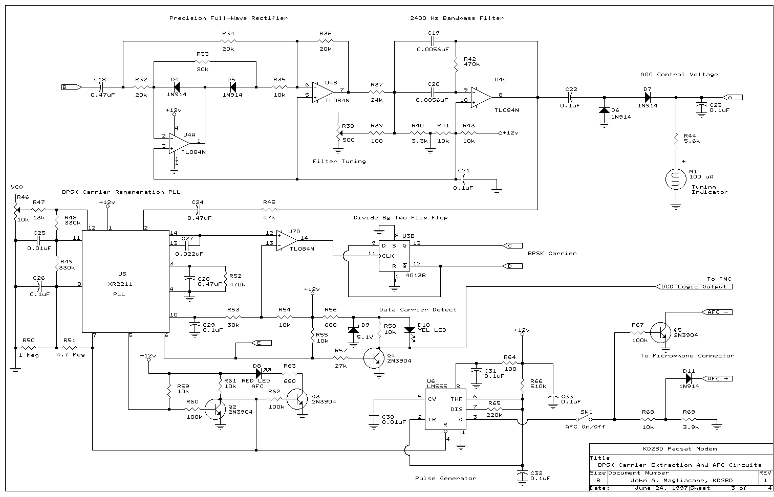

Figure 3: Schematic showing the carrier recovery, data carrier detect, and AFC circuitry.

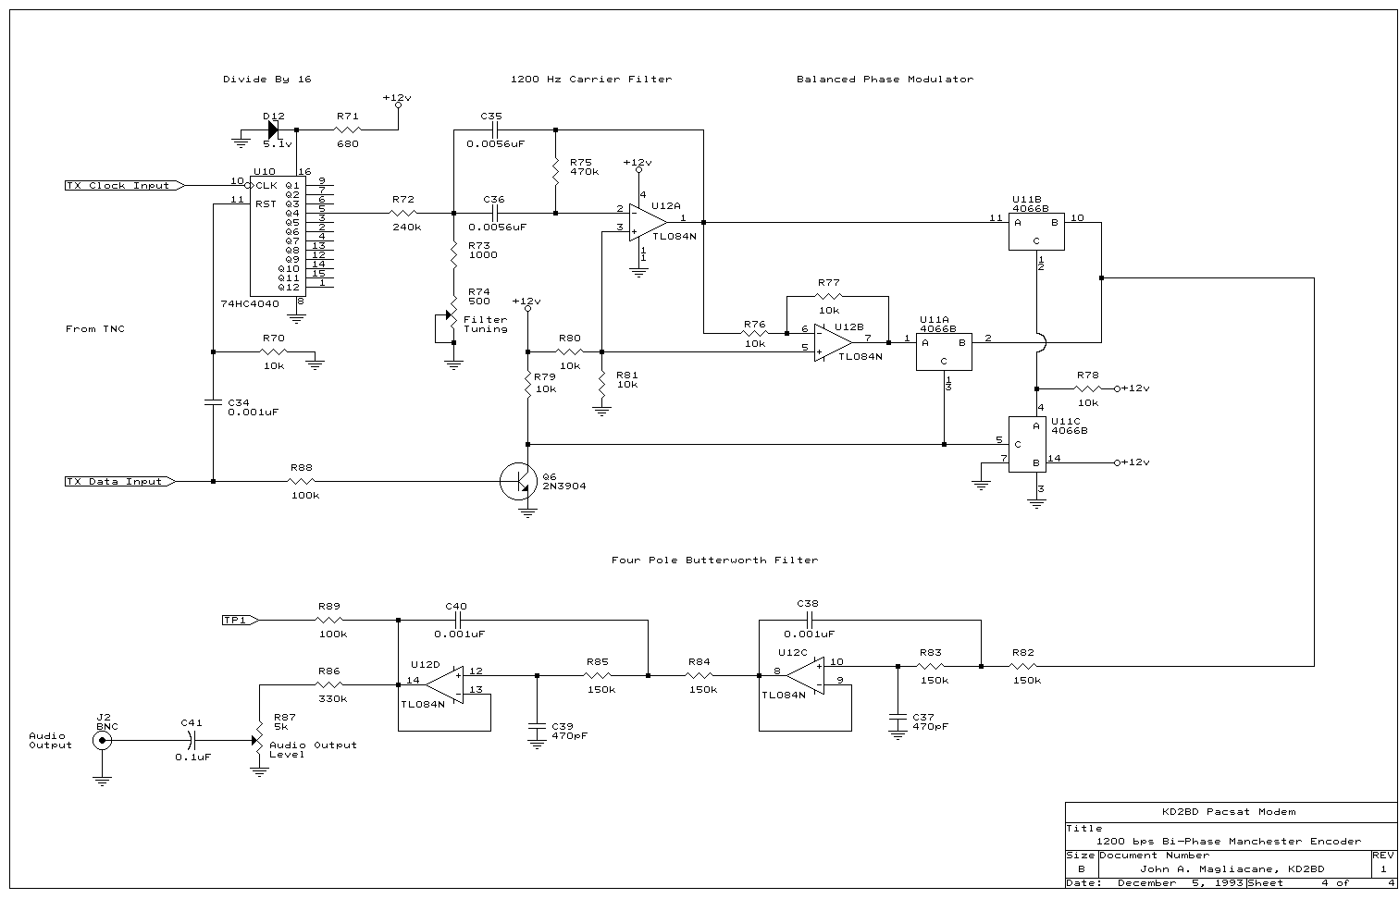

Figure 4: Schematic showing the transmit encoder and filter.

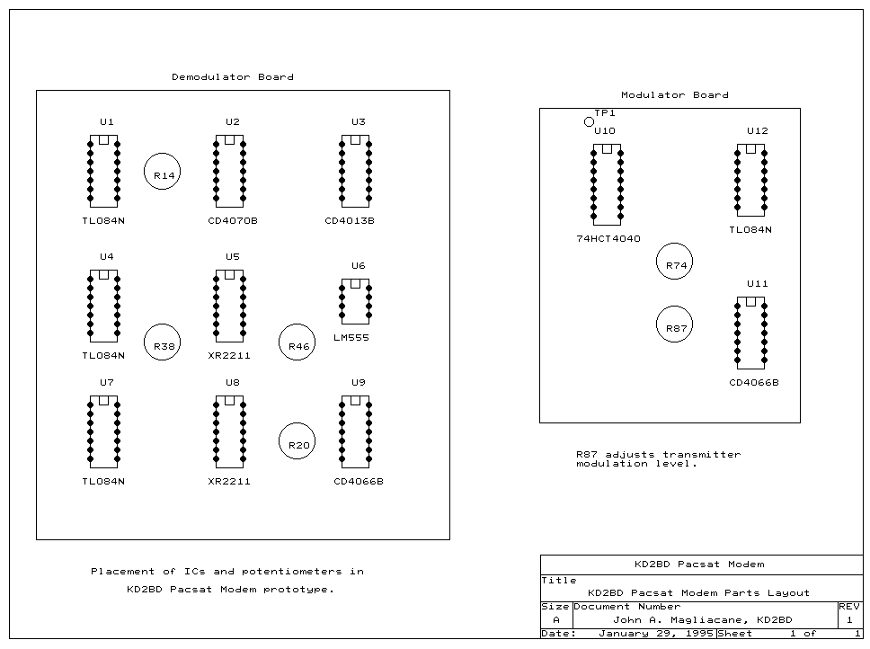

Figure 5: Parts layout of the KD2BD Pacsat Modem prototype.

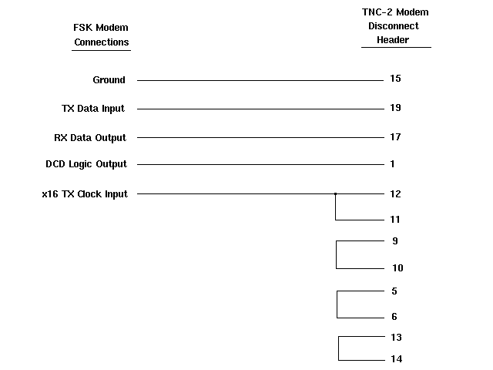

Figure 6: Connections between the KD2BD Pacsat Modem and a TAPR TNC-2 or clone. Consult your TNC manual to determine the connections for other TNCs.

[*John A. Magliacane, KD2BD*](http://www.qsl.net/kd2bd/)